

**Placement Empowerment Program**

***Cloud Computing and DevOps Centre***

Set Up Git Branching

Name: Harivasan S

Department: ADS



# Introduction :

Git is a robust version control system that helps track code changes and enables multiple developers to collaborate seamlessly. It prevents conflicts by allowing independent development.

Core concepts include:

* **Repositories**: Store project files and their version history.
* **Branches**: Separate development lines for different features or fixes.
* **Commits**: Save changes with unique identifiers and messages.
* **Merges**: Combine updates from different branches.
* **Pulling**: Retrieve the latest changes from a remote repository.
* **Pushing**: Upload local changes to a remote repository.
* **Cloning**: Create a local copy of a remote repository.

# Step-by-Step Overview :

Step 1:

Create the repository.

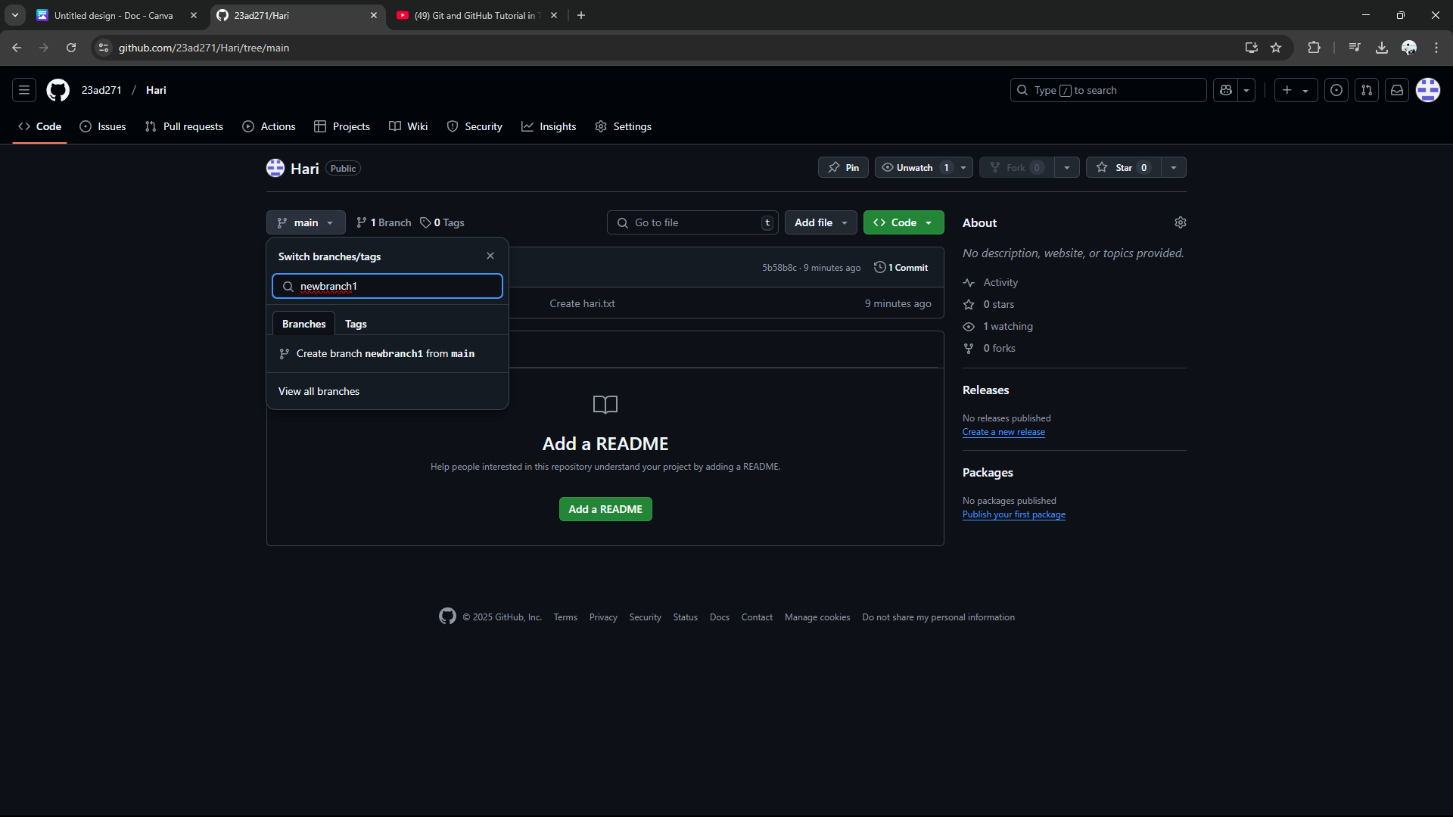

## Step 2:

## Check the branch status

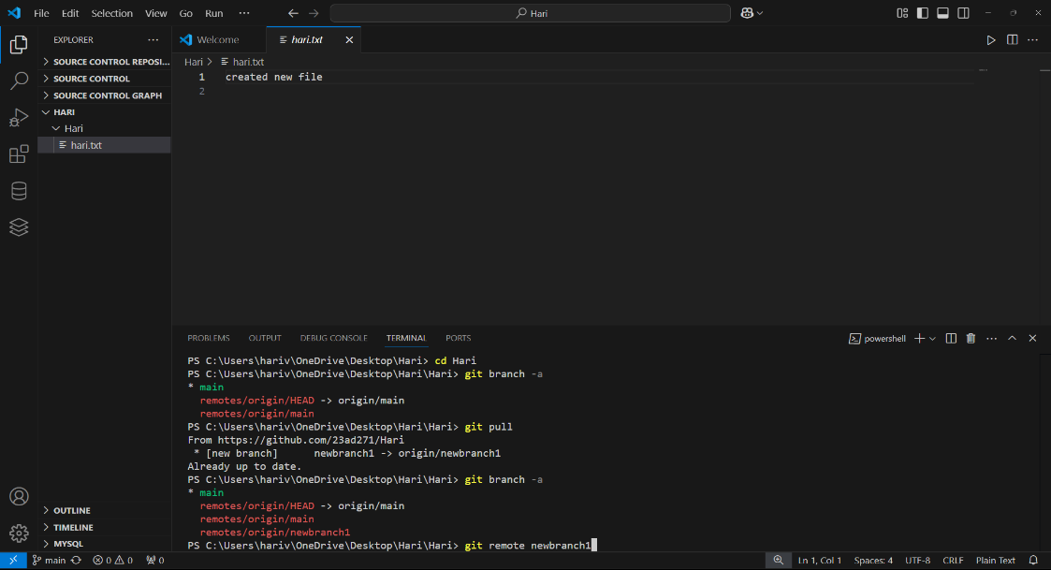

## Step 3 :

Pull this branch into an github by using an comment **“git pull”**

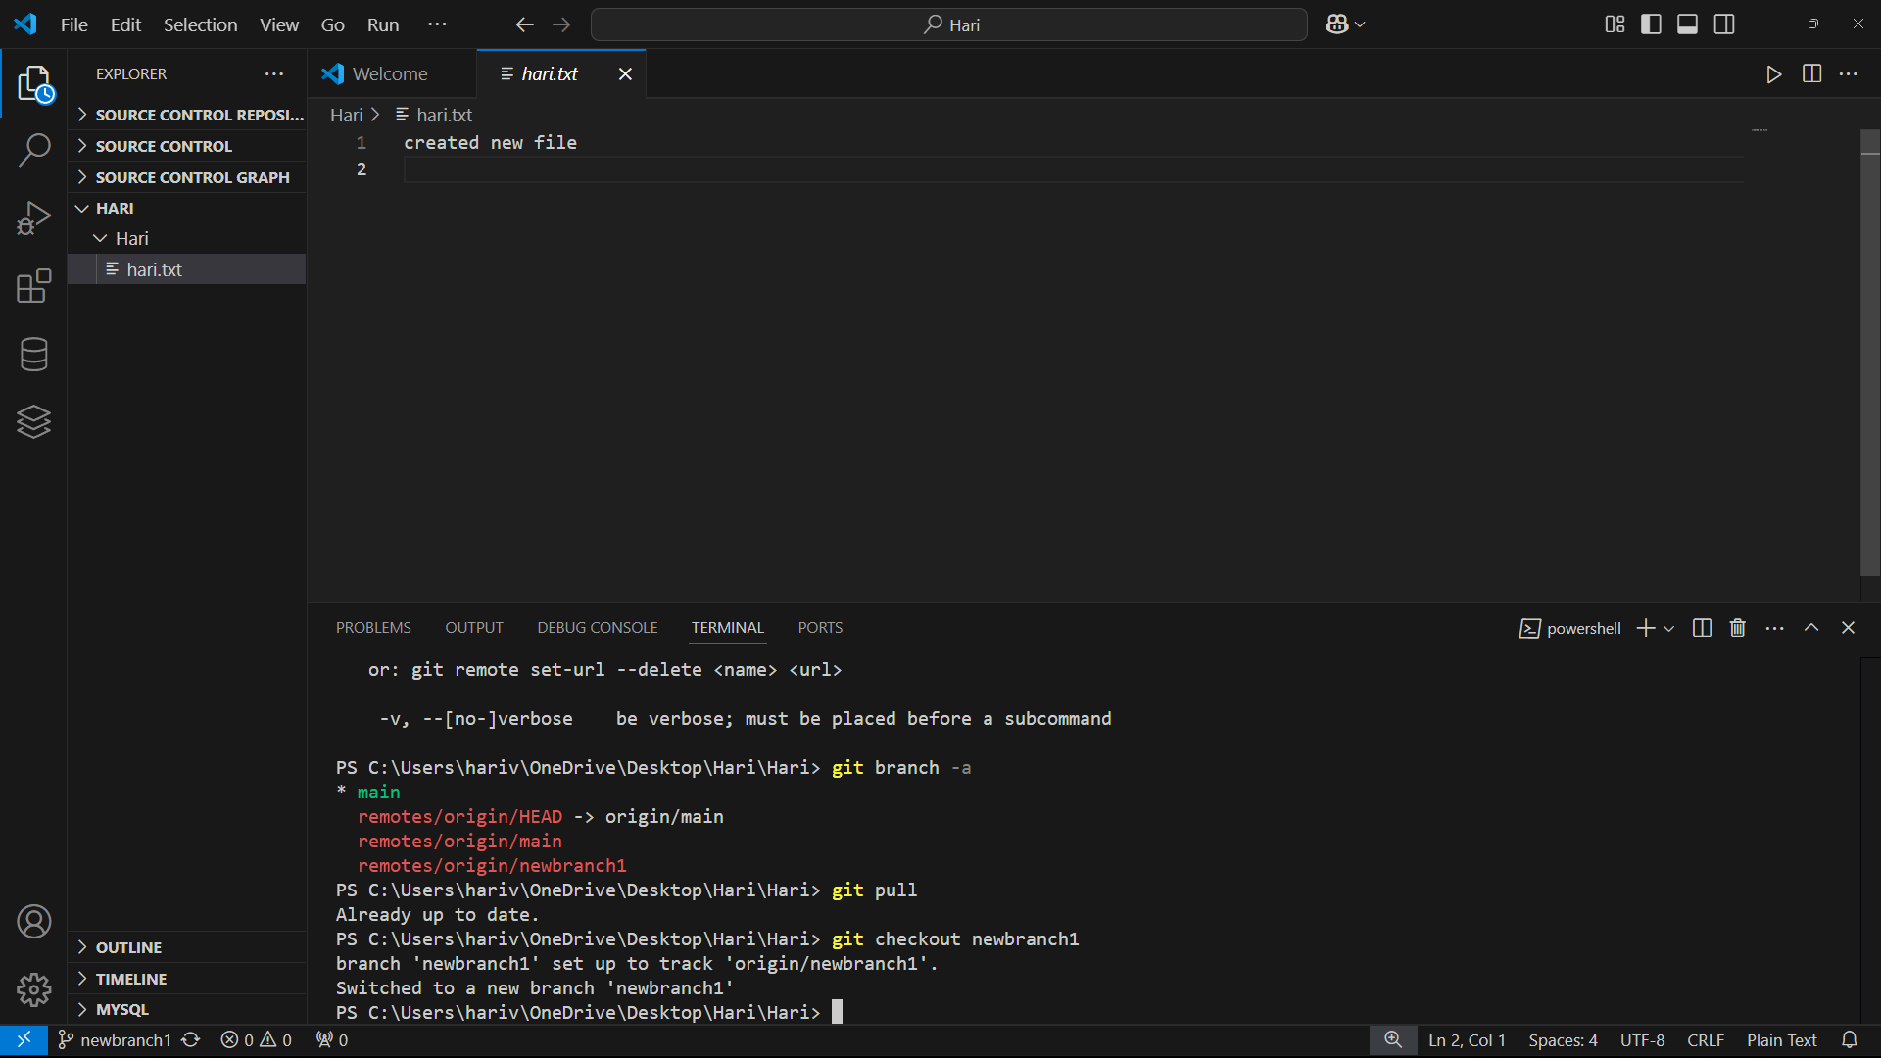

Step 4:

Add file in new branch and know the status of that branch

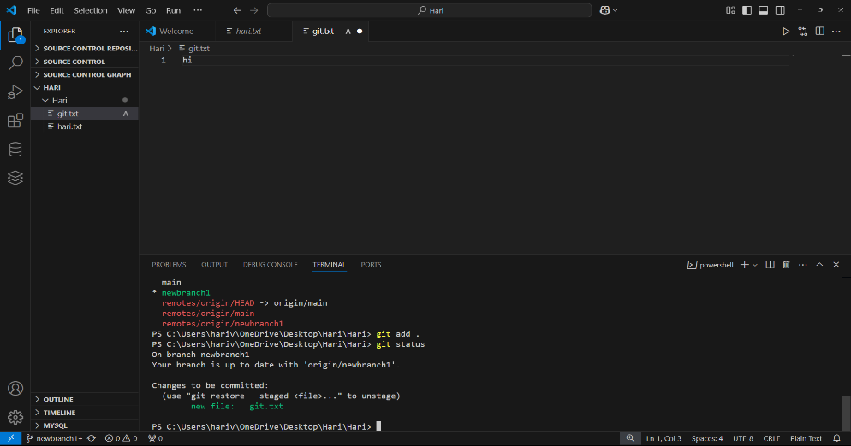

## Step 5:

**Push Your Branch to Main**:

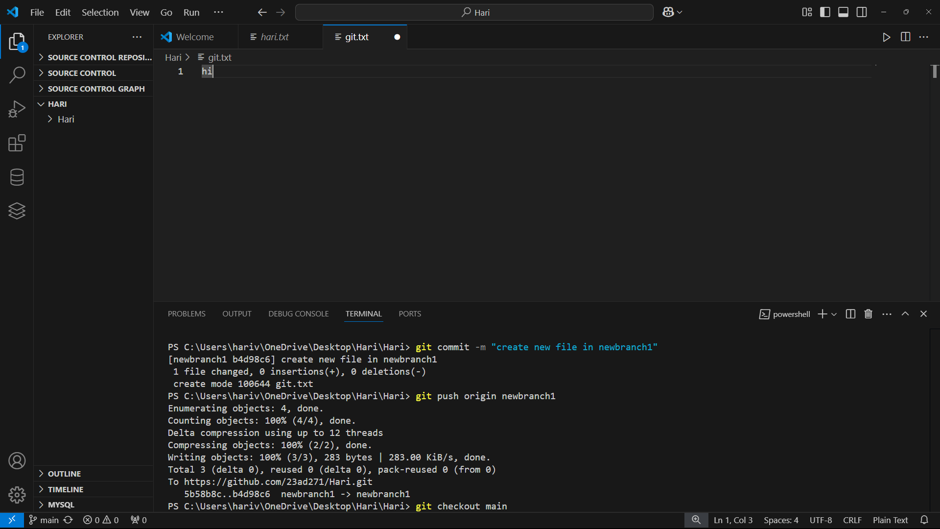

## Step 6:

Successfully the new branch with an github

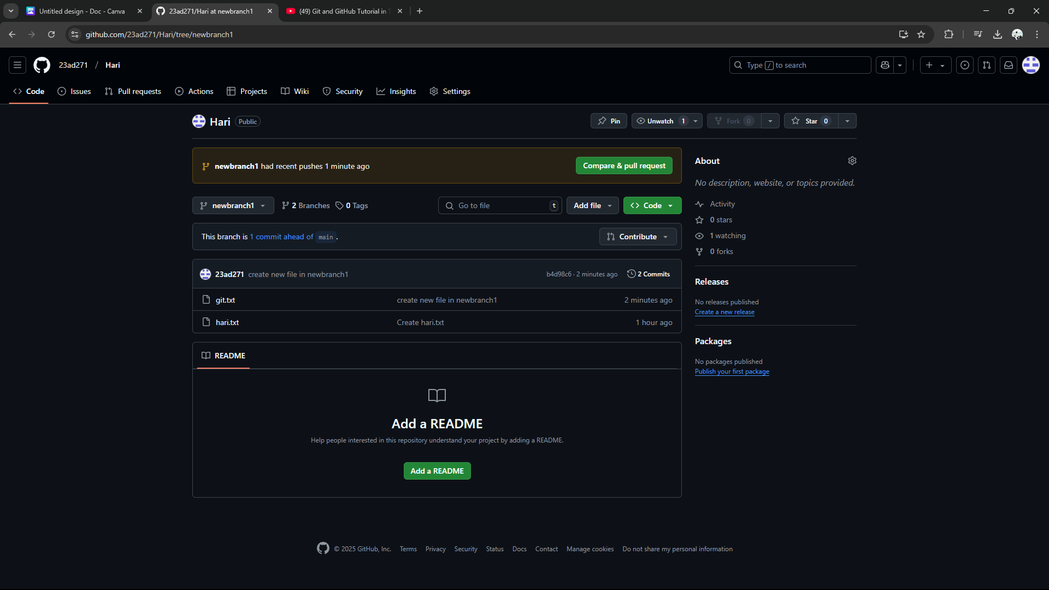

## Step 7 :

After Merging the Branch Switch back to main branch:

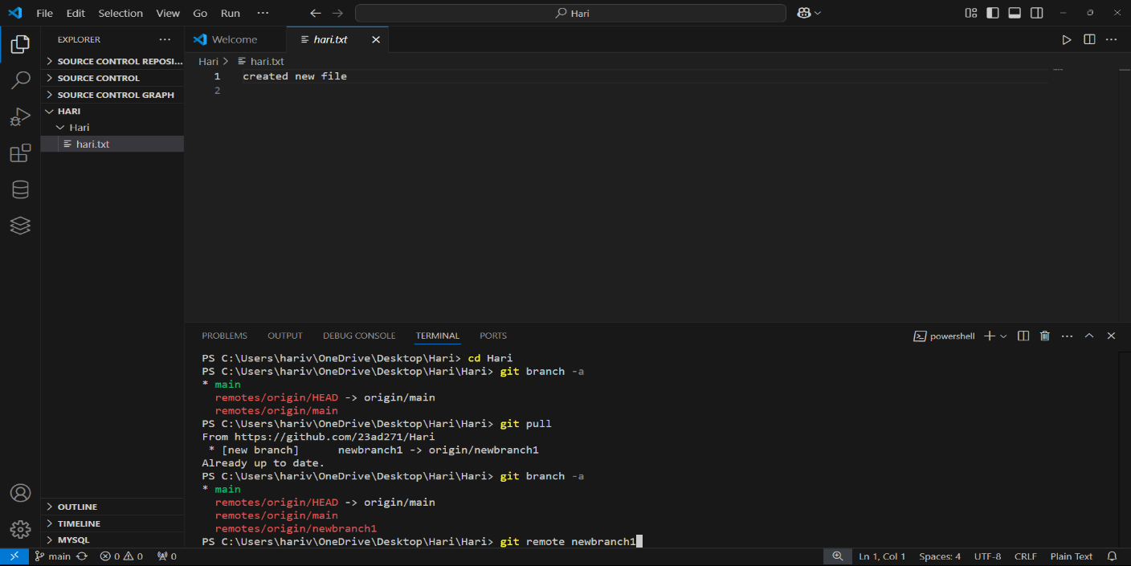

# Expected Outcome :

1. **Create and Commit**: Navigate to the repo, create a branch (git checkout -b new-feature-branch), add changes, stage (git add), and commit (git commit -m "message").

2. **Push to Remote**: Push the branch (git push origin new-feature-branch).

3. **Merge and Push**: Switch to main (git checkout main), merge (git merge new-feature-branch), and push (git push origin main).